1.27 Dual System Linkage

For the final product of MVP, I started to develop the purchasing part. The purchase of goods in the store involves both the point monitoring system and the good management system, forming a dual-system linkage. For this part, MVP standard is:
- User can view information such as the good’s name, quantity, price, description, and images.
- There is a shopping cart to record the purchased items and the total price.
- User can add goods to shopping cart.
- Select the buyer and operator to complete a checkout. Deduct the student's points, record the points transaction history, and update the inventory.
Also, two key practical constraints were considered when designing the structure:
- Students' points will only be modified during non-purchasing times such as class time, preventing situations where points are updated while purchases are being made.
- The school currently has only one operator, so there is no need to worry about multi-threaded operations causing the product quantity to become negative.
This part was added to the good management system's file. Using two different tabs to quickly switch between good management and purchasing better meets real-world needs. Similarly, a three-tier structure of data layer-structure layer-rendering layer is used.
Tab switching part:
Use activeTab records the current tab (inventory or shop). renderCurrent() function renders different tab based on activeTab. When user clicks tab button, title, subtitle, selected state as well as activeTab will change.
Data layer:
All goods information comes from items. This information is shared with the good management system and will not be described further in this log.
The cart array contains the item_id and corresponding quantities in the shopping cart. When modifying a cart, the corresponding good is found by iterating through its ID and then modified its quantity (e.g., changing quantity, adding quantity). A restriction is added here: the quantity of an item in the shopping cart can only be less than or equal to the quantity in the data base.

Structure layer:
The structure of this page can be divided into three parts: goods card, shopping cart as well as checkout section (As shown in Fig.R1). The format and principle of goods card are exactly the same as those of goods management system, so I won’t go into details here.

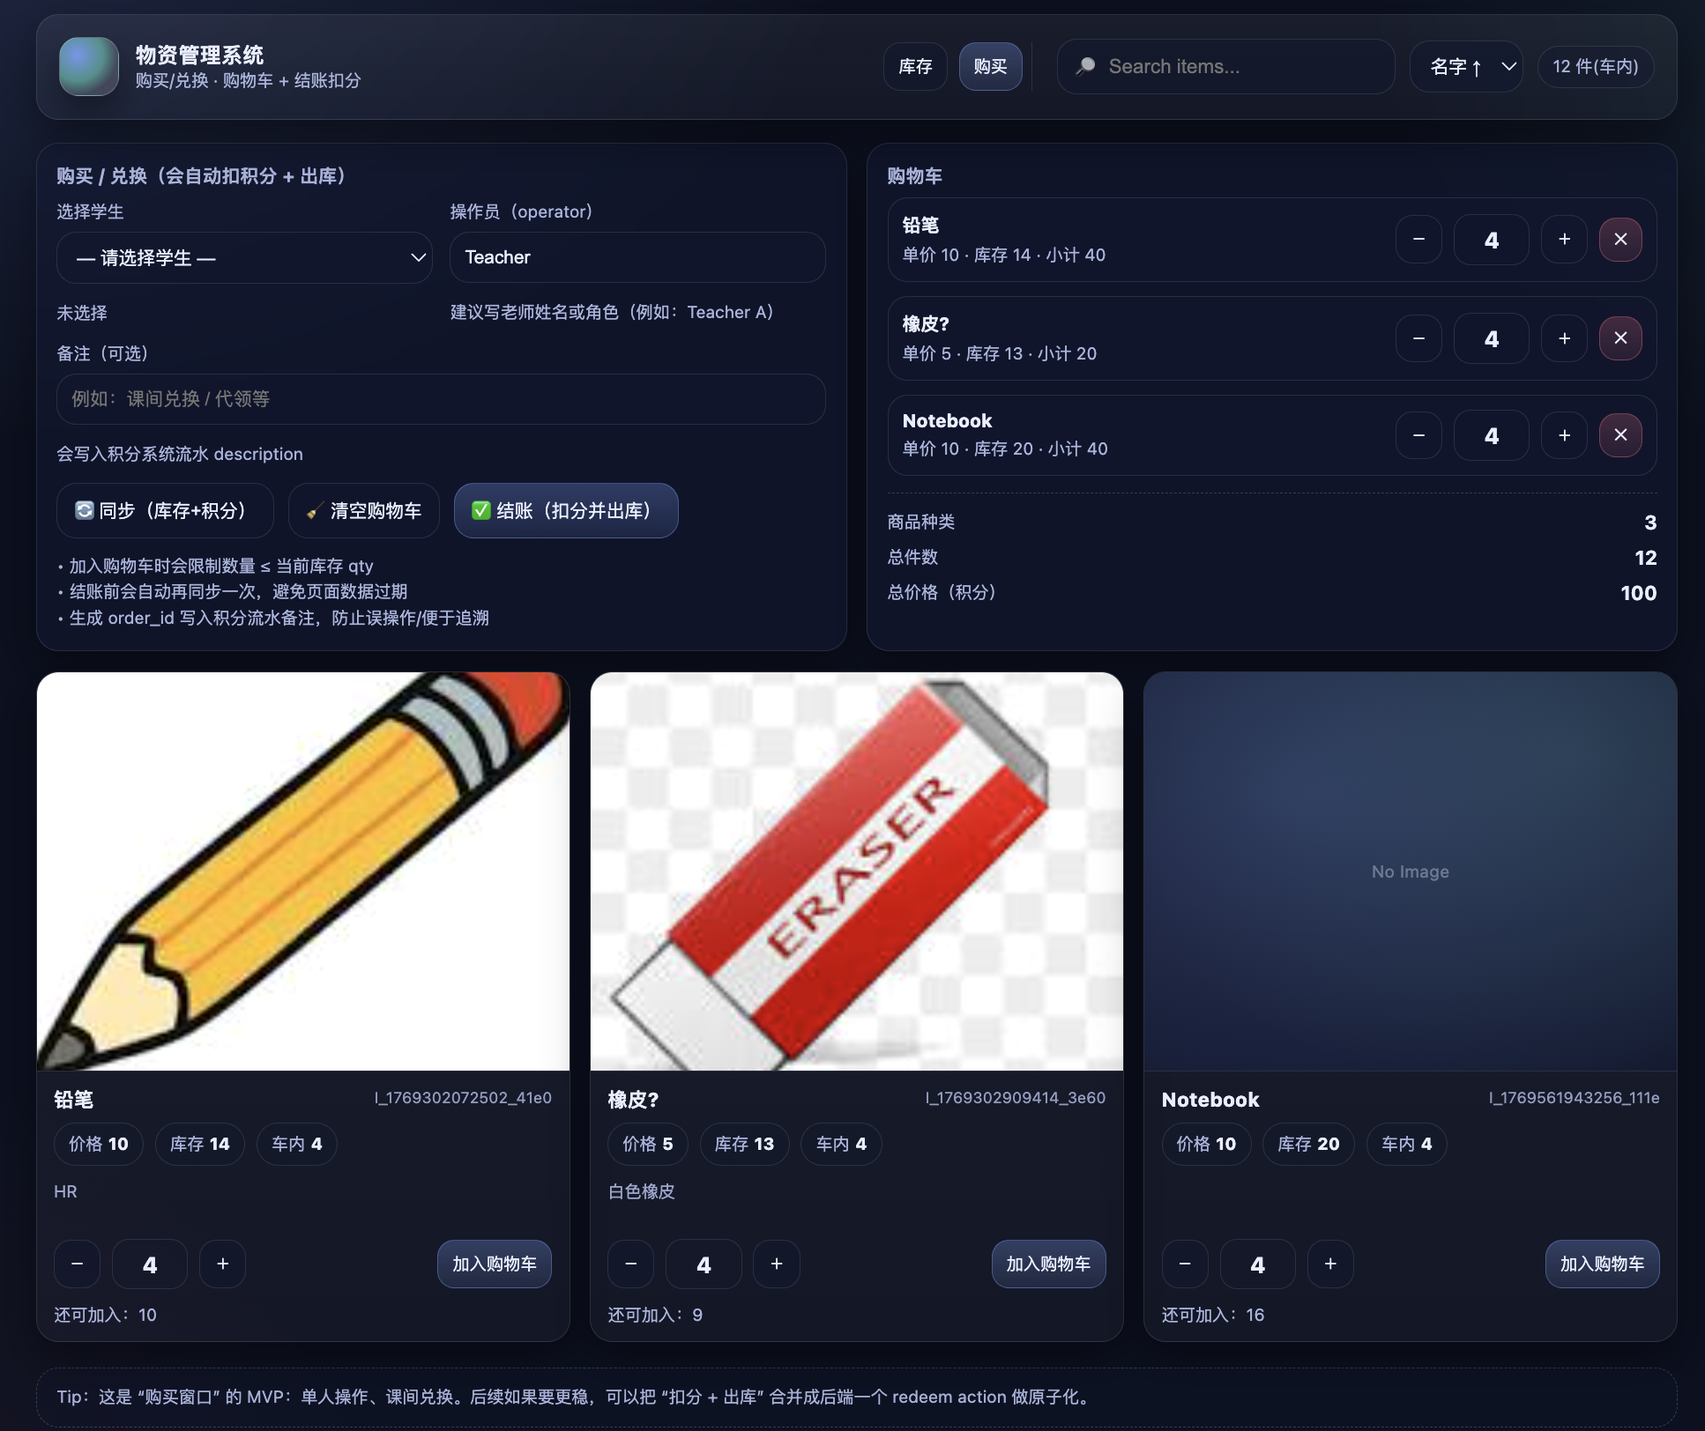
Fig.R1. The structure of shopping page

The shopping cart section is quite similar as the goods card, recording the types of items purchased and brief information. Its structure belongs to this layer, while the actual good cards in the shopping cart are rendered.
The checkout area is primarily used for operators to input information that generates points records (student name, operator, description). This area also includes commonly used buttons (synchronize inventory and student points, clear shopping cart).
Rendering layer:
When rendering the entire page, the main things to pay attention to are the goods card and shopping cart. The rendering of the goods card is the same as the previous system. The principle behind rendering a shopping cart is similar. It iterates through all [item_id, qty] pairs in the cart, and then retrieves the quantity, price, and other information of each item from the items using each item_id. Finally, it embeds fixed card templates and renders them one by one. Finally, bind the button and trigger functions.
Checkout:
The logic of the entire page is similar to that of the good management system. However, the checkout process requires additional explanation. The entire checkout process can be divided into four steps.
Step one: check the cart. First, freeze the entire page and display a waiting message box. Then, check the student's points and whether the items in the shopping cart meet the requirements (e.g., insufficient points, incorrect prices).
Step two: deduct student points. The data is combined into a point log. It is then uploaded to the database using the appendPointEvent() method.
Step three: each item in cart was taken out of the database one by one. Iterate through all item_id in the cart, deduct the quantity of each item (existing quantity - purchased quantity), and upload the newly calculated quantity to the database via postAction() with action = updateItem.
Step four: reset. Clear the cart, reset the information, and a checkout success message will pop up and the entire page will be unfrozen.
Checkout is achieved by sending multiple request messages to the database. The advantage of this approach is its ease of implementation and straightforward principle. The disadvantages are its long processing time and lack of stability (manual intervention is required if some requests time out).
In future development, I can consider combining items in the cart into a single composite message, transmitting it to the database via a single postAction(), and then disassembling and updating it in the database.

